AI ASSISTANT CODING ASSIGNMENT 2

Name: Thrishala Jakkaraju
Hall ticket: 2303A51514
Batch:22

Exploring Additional AI Coding Tools beyond Copilot – Gemini (Colab)
and Cursor AI
Lab Objectives:
❖ To explore and evaluate the functionality of Google Gemini for AI-
Week1 -
Monday
assisted coding within Google Colab.
❖ To understand and use Cursor AI for code generation, explanation,
and refactoring.
❖ To compare outputs and usability between Gemini, GitHub Copilot,
and Cursor AI.
❖ To perform code optimization and documentation using AI tools.
Lab Outcomes (LOs):
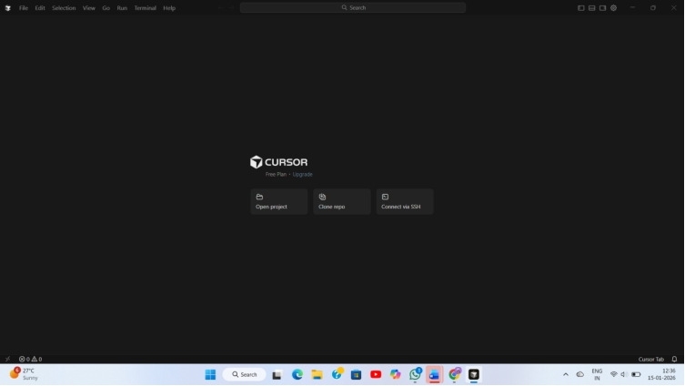
After completing this lab, students will be able to:
❖ Generate Python code using Google Gemini in Google Colab.
❖ Analyze the effectiveness of code explanations and suggestions by Gemini.
❖ Set up and use Cursor AI for AI-powered coding assistance.
❖ Evaluate and refactor code using Cursor AI features.
❖ Compare AI tool behavior and code quality across different platform.

Task 1: Cleaning Sensor Data
❖ Scenario:
❖ You are cleaning IoT sensor data where negative values are invalid.
❖ Task:
Use Gemini in Colab to generate a function that filters out all negative
numbers from a list.
Code/output:
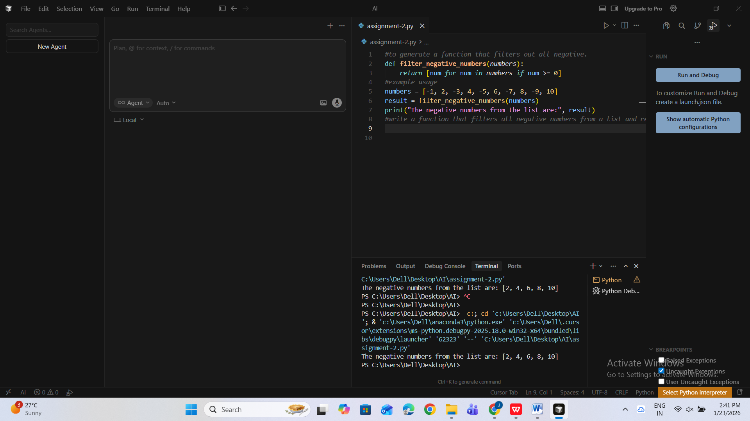
➢ Before/after list
➢ Screenshot of Colab execution.

Task 2: String Character Analysis
❖ Scenario:
You are building a text-analysis feature.
❖ Task:
Use Gemini to generate a Python function that counts vowels, consonants,
and digits in a string.
❖ Expected Output:
➢ Working function
➢ Sample inputs and outputs.
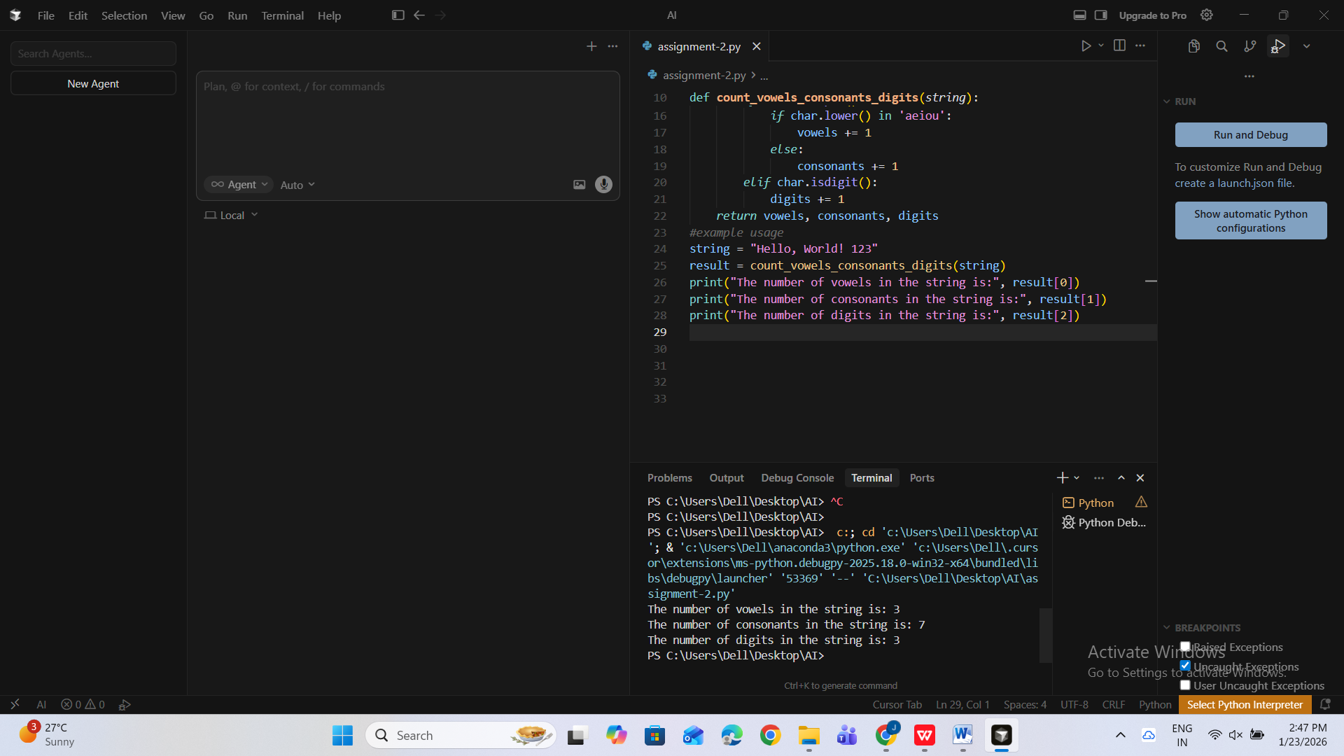

Task 3: Palindrome Check – Tool Comparison
❖ Scenario:
You must decide which AI tool is clearer for string logic.
❖ Task:
Generate a palindrome-checking function using Gemini and Copilot, then
compare the results.
❖ Expected Output:
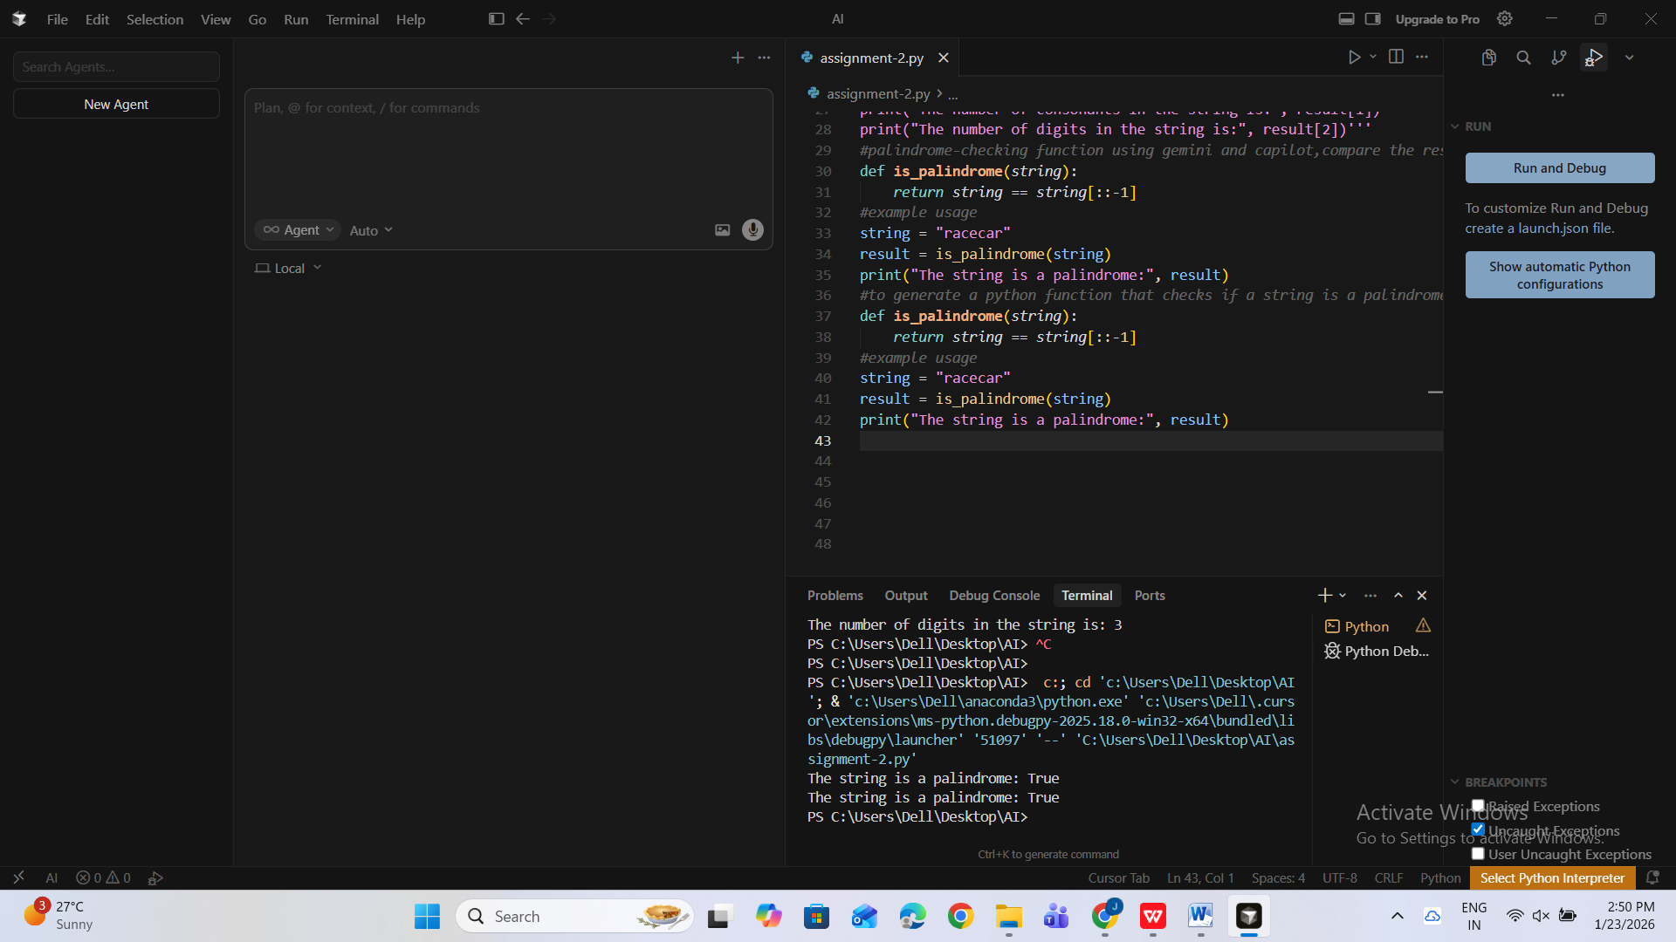
➢ Side-by-side code comparison
➢ Observations on clarity and structure
Task 4: Code Explanation Using AI
❖ Scenario:
You are reviewing unfamiliar code written by another developer.
❖ Task:
Ask Gemini to explain a Python function (prime check OR palindrome
check) line by line.
❖ Expected Output:
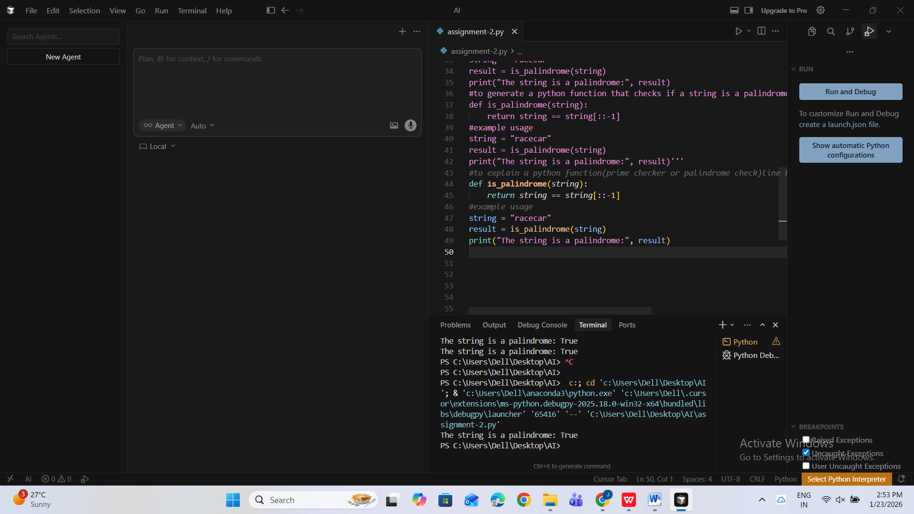
➢ Code snippet
➢ AI explanation
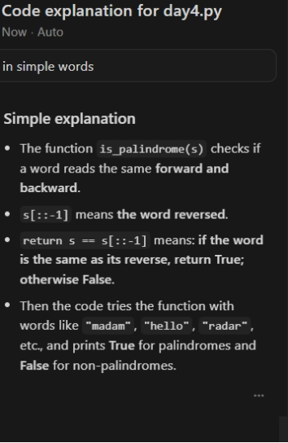
➢ Student comments on understanding

My own experience using both Gemini and Cursor Ai and GitHub Copilot:
While using Cursor Ai, I found the explanations to be very clear and helpful in understanding the logic behind the code. Cursor was especially useful for learning and analyzing Python programs step by step. GitHub Copilot, was faster in generating code directly inside the editor and helped me complete tasks quickly. Copilot felt more suitable for continuous coding, while Gemini was better for conceptual clarity. Overall, using both tools together improved my coding efficiency and understanding

